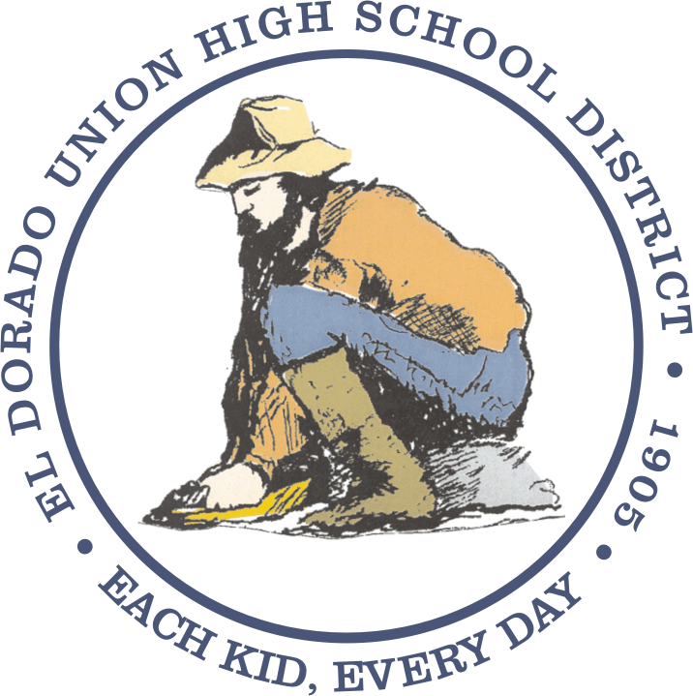
EL DORADO UNION HIGH SCHOOL DISTRICT
4675 Missouri Flat Road, Placerville, CA 95667
(530) 622-5081

Notice to Parents / Guardians,
Students, and Teachers
COMPLAINT RIGHTS
(Under the Williams Uniform Complaint Procedure)

Education Code 35186(f) requires that the following notice be posted in your child’s classroom. Parents/Guardians, students, and teachers are hereby notified that:

1. There should be sufficient textbooks and instructional materials. Each student, including English learners, must have a textbook or instructional materials, or both, to use in class and to take home.

2. School facilities must be clean, safe, and maintained in good repair.

3. There should be no teacher vacancies or misassignments. There should be a teacher assigned to each class and not a series of substitutes or other temporary teachers. The teacher should have the proper credential to teach the class, including the certification required to teach English learners, if present.

Teacher vacancy means a position to which a single designated certificated employee has not been assigned at the beginning of the year for an entire year or, if the position is for a one-semester course, a position to which a single designated certificated employee has not been assigned at the beginning of a semester for an entire semester.

Misassignment means the placement of a certificated employee in a teaching or services position for which the employee does not hold a legally recognized certificate or credential; or, the placement of a certificated employee in a teaching or services position that the employee is not otherwise authorized by statute to hold.

4. A complaint form may be obtained at the school office or district office, or downloaded from the school or district website. You may also download a copy of the California Department of Education complaint form from the website at http://www.cde.ca.gov/re/cp/uc. However, a complaint need not be filed using either the district’s complaint form or the complaint form from the California Department of Education.

The El Dorado Union High School District strives to resolve concerns as expeditiously as possible. To report a concern regarding sufficient textbooks and instructional materials, please call Christopher Moore at the district office at (530) 622-5081, ext. 7226. To report a concern regarding teacher assignments, credentials, or subject matter training, please call Steve Wehr at the district office at (530) 622-5081, ext. 7214. To report a concern regarding clean and safe classrooms or restrooms, please call Dan Augino at the district office at (530) 622-0140. We are committed to providing your child with textbooks and instructional materials, qualified teachers, and classrooms that are clean and safe.

